Ecem, I am so excited to have you help me with this project. I’ve created a few websites, but I’m having a hard time coming up with good ideas for this project. So, if you have any suggestions, please share them. Your expertise and experience will help me.

Here is the access information:
New Author Domain: reneelizbryan.info
RENEELIZ
login: https://ded4191.inmotionhosting.com:2083 cp user: reneeliz pw: ?rQGXapv4vb~
Host : 209.182.205.202 Port: 21
WP LOG IN: renee@wrongwaylizzie.me PW: ?rQGXapv4vb~
https://reneelizbryan.info/wp-login.php
Main Ideas/Pages:
- Highlight my book
- Tell them about me, the author
- Explain my background as a financial instructor at Bryan Ventures, Inc. (https:bryanventures.com)
- Link to my blog: https://wrongwaylizzie.me
- Gain subscribers to my YouTube channel: https://www.youtube.com/@Fearless_Finances

Here are some of my other social media sites mainly related to YouTube:

This is a picture of the cover of the book:
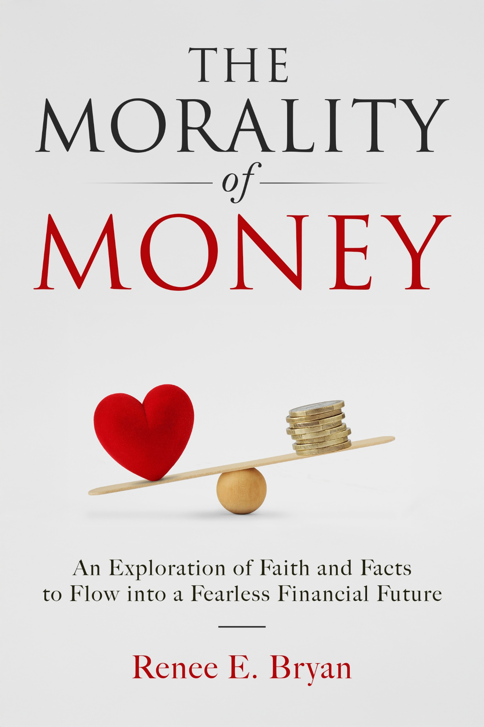
Here is a picture I thought about for the back cover:


I don’t know. I can’t choose what is best half the time.
This is the current description:
THE MORALITY OF MONEY
Renee E. Bryan
A Faith-filled Journey to
Financial Freedom

Are you feeling weighed down by financial worries? Concerned about your future and the decisions that could impact your life? You're not alone—over three-quarters of Americans share these anxieties, and nearly half say such worries affect their mental well-being.

But what if you could break free from this cycle of fear?

In The Morality of Money, bestselling author and financial expert Renee E. Bryan reveals the secrets of achieving true financial security. With over 35 years in the financial services industry, Renee transformed a devastating loss into a faith-filled journey toward prosperity, uncovering insights that promise to motivate you.

Rich with compelling real-life examples, historical economic perspective, and hard-hitting facts, this book offers a refreshing dose of hope that challenges the doom-and-gloom narratives often spread by so-called experts.

No matter where you are on your financial journey, this book will help you pave the way to a brighter future. With Renee's straightforward and honest approach, you’ll discover how to turn fear into empowerment and unlock a life you may have never imagined possible.

Join the countless others who have transformed their lives by embracing Renee’s faith-driven strategies. Begin your journey toward fearless financial success today with The Morality of Money—your path to a secure and fulfilling future awaits!

This will tell you a little bit about me and my work career, but please go anywhere on either site, wrongwaylizzie and bryanventures, and take anything you think is helpful:
https://bryanventures.com/about/
https://wrongwaylizzie.me/about-wrongwaylizzie/

